Message: As seen in the box, whenever we try to type in a message, the word message doesn’t instantly disappear when we click on it! I have also tried sending messages to both Dubai and Beirut and didn’t get any on our info email. Please make sure to redirect the Contact us messages to our email.

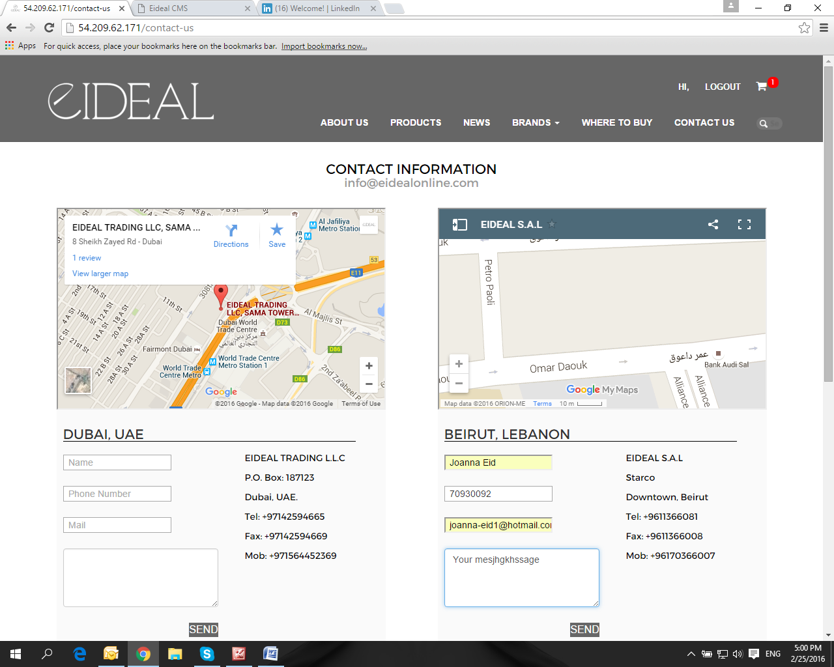

**Done**

Careers: I tried to fill out the application form and you have mentioned that it was redirected to our email, however this is the error page I got!

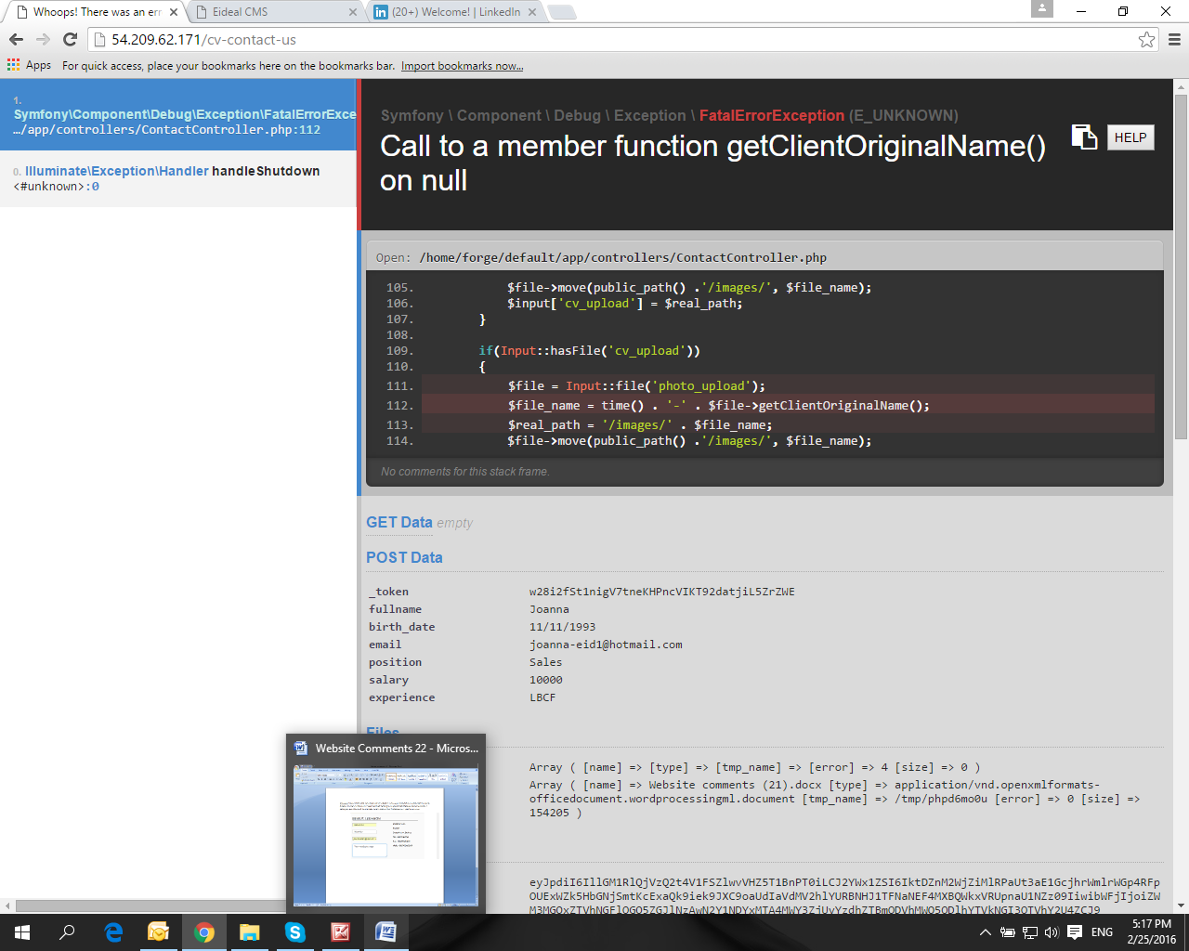

**Done**

Retrieve Password: my colleague previously had an account on our old website, so he tried to log in immediately but couldn’t and when he tried to retrieve his password he got this error page.

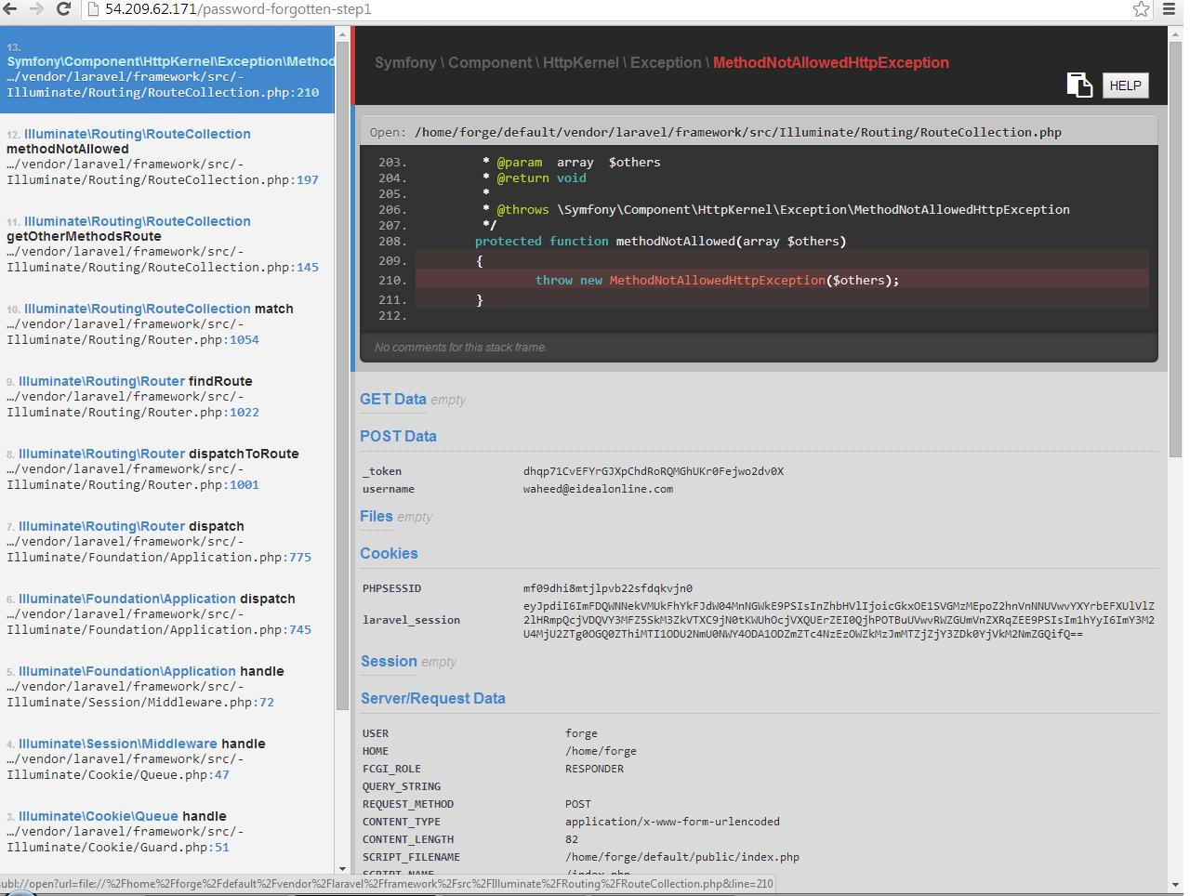

**Done, bug fixed.**

**Please note that the accounts in your old website are not related to the new one. We do not have access to the old database, therefore all the old users in the old website will not be in the new one. So if your colleague is trying to log in with the account of the old website, it is definitely not going to work.**

Log In: also when we try to log in, for some reason the phone number automatically appears and not the username.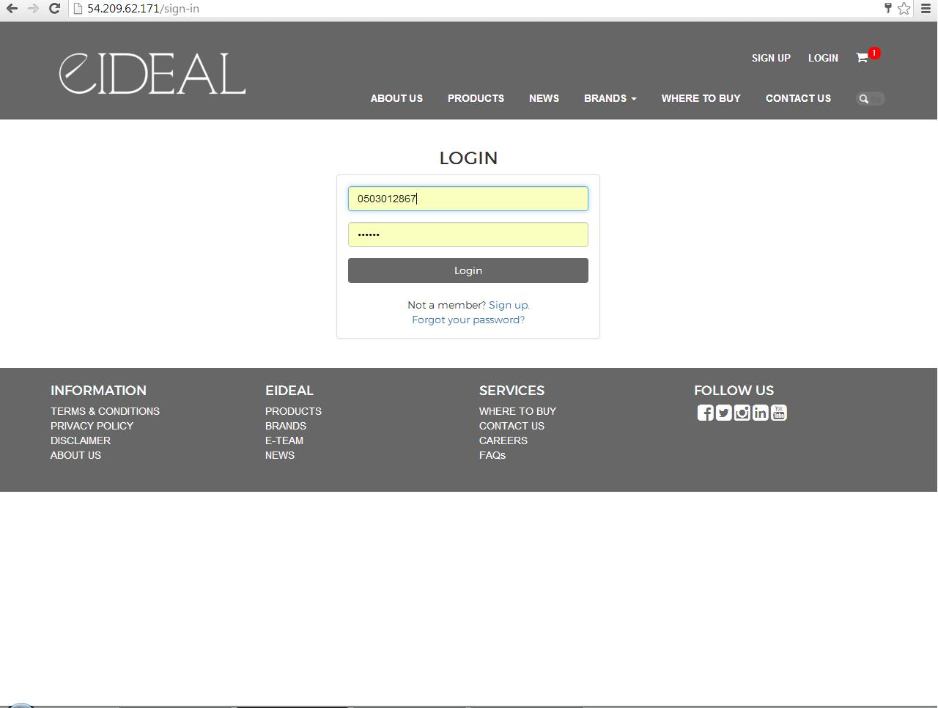

**The phone number is appearing due to the history of your browser, it has nothing to do with the website. I you clear your history browser or you change a browser the number will disappear.**